The usage of fasting glucose and glycated hemoglobin for the identification of unknown type 2 diabetes in high risk patients with morbid obesity.
Running title: Screening for DM2 in morbid obese

Tone G Valderhaug^{1,3}, Archana Sharma¹, Gunnhild Kravdal², Reidun Rønningen¹, Ingrid Nermoen^{1,3}.

¹Department of Endocrinology, Akershus University Hospital HF, Lørenskog, Norway
² Multidisciplinary Laboratory Medicine and Medical Biochemistry, Akershus University Hospital HF, Lørenskog, Norway
³Division of Medicine and Laboratory Sciences, Institute of Clinical Medicine, University of Oslo, Norway,

Word count: Abstract: 244 Manuscript: 3022 Tables: 2 Figures: 3

Corresponding author: Tone Gretland Valderhaug, Division of Medicine, Department of Endocrinology, Akershus University Hospital, Sykehusveien 25, 1478 Nordbyhagen
Email addresses: Tone G. Valderhaug: t.g.valderhaug@medisin.uio.no
Archana Sharma: archana.sharma@ahus.no
Gunnhild Kravdal: gunnhild.kravdal@ahus.no
Reidun Rønningen: reidun.ronningen@ahus.no
Ingrid Nermoen: ingrid.nermoen@ahus.no

ABSTRACT
Background: In spite of increased vigilance of undiagnosed type 2 diabetes (DM2), the prevalence of unknown DM2 in subjects with morbid obesity is not known.
Aims: To assess the prevalence of undiagnosed DM2 and compare the performance of glycated A1c (HbA1c) and fasting glucose (FG) for the diagnosis of DM2 and prediabetes (preDM) in patients with morbid obesity.
Patients and methods: We measured fasting glucose and HbA1c in 537 consecutive patients with morbid obesity without previously known DM2.
Results: A total of 49 (9%) patients with morbid obesity had unknown DM2 out of which 16 (33%) fulfilled both the criteria for HbA1c and FG. Out of 284 (53%) subjects with preDM, 133 (47%) fulfilled both the criteria for HbA1c and FG. Measurements of agreement for FG and HbA1c were moderate for DM2 (κ=0.461, (p<0.001) and fair for preDM (κ=0.317, p<0.001). Areas under the curve for FG and HbA1c in predicting unknown DM2 were 0.970 (95% CI 0.942, 0.998) and 0.894 (0.837, 951), respectively. The optimal thresholds to identify unknown DM2 were FG ≥6.6 mmol/L and HbA1c ≥6.1% (43 mmol/mol).
Conclusion: The prevalence of DM2 remains high and both FG and HbA1c identify patients with unknown DM2. FG was slightly superior to HbA1c in predicting and separating patients with unknown DM2 from patients without DM2. We suggest that an FG ≥6.6 mmol/L or an HbA1c ≥6.1% (43 mmol/mol) may be used as primary cutpoints for the identification of unknown DM2 among patients with morbid obesity.

Key words: Morbid Obesity, Type 2 diabetes, Hyperglycemia, Glycated A1c, Prediabetes, Glucose screening tests.

BACKGROUND
The prevalence of type 2 diabetes (DM2) in populations with obesity varies between 11-30 % depending on race and risk factors within the population studied [1-3]. Cardiovascular disease (CVD) is the leading cause of morbidity and premature death in patients with DM2 [4]. Complications associated with glucose abnormalities may appear from prediabetic stages of the disease [5]. Consequently, early identification of high risk patients is imperative to provide the best treatment strategies that reduce future health hazards from obesity and improve quality of life at an individual level. The American Diabetes Association (ADA) recommends that all adults are screened for DM2 at the age of 45 years, regardless of weight [6]. Testing is also recommended for asymptomatic adults of any age who are overweight or obese and who have one or more additional risk factors for diabetes [6]. Consequently, patients with morbid obesity should all have been tested before referral to a specialist care center for obesity. Nevertheless, the prevalence of undetected DM2 in parallel with increased awareness of diabetes risk with increased BMI is not known in patients with morbid obesity.
In patients with no symptoms, a glucose measurement above the diagnostic threshold for DM2 (i.e. random glucose≥ 11.1 mmol, fasting glucose [FG] ≥ 7.0 mmol/L, 2 hour glucose [2HG] during an oral glucose tolerance test [OGTT] ≥ 11.1 mmol/L or glycated A1c [HbA1c] ≥ 6.5 % [48 mmol/mol]), should be verified by a confirmatory test [7]. The available glucose measurements are considered equally important in the diagnosis of diabetes. However, the three tests for diabetes have insufficient overlap and identify individuals with different glucometabolic profiles [8]. HbA1c is associated with higher reliability compared with the reliability of other tests of glycemia [9]. Widespread usage of an OGTT may not be considered acceptable due to considerable inconvenience for the patients and health personnel involved. One study of patients with morbid obesity reported an overlap between FG and 2HG for the diagnosis of DM2 of 45 % [1]. The validity of HbA1c in the diagnosis of DM2 in patients with morbid obesity is not known.
The aim of the present study was to assess the prevalence of unknown DM2 in patients with morbid obesity in the southeast region of Norway. Furthermore, we wanted to compare the diagnostic accuracy of FG with the accuracy of HbA1c for the diagnosis of DM2 and preDM in patients with morbid obesity.

METHODS
Design and study population
This cross-sectional study was conducted at a specialist care center in the southeast region of Norway. Treatment-seeking individuals with morbid obesity referred from primary health care physicians and who accepted to be enrolled in the Registry study at the Section for Morbid Obesity at Akershus University Hospital HF, Lørenskog, Norway, during the period from January 3rd 2014 until December 31th 2016 were consecutively assessed for eligibility. A total of 700 patients were assessed for eligibility at our specialist care center, 149 (21 %) patients with previously known diabetes mellitus (DM1: n=5 and DM2: n=144) were not included for the screening analysis for unknown diabetes. The patients with known DM2 (n=144) were included for the analysis of the DM2 prevalence among patients with morbid obesity. Fourteen patients had missing data on glucose variables (HbA1c: n=14 and FG: n=11) and were excluded from the study leaving a total of 537 patients with morbid obesity to be included in the analysis. The majority of patients were Caucasian (n=513 [96 %]). The study was approved by the Regional Committee for Medical and Health Research Ethics. The participants were included after providing written informed consent. The study was performed in accordance with the Declaration of Helsinki [10].

Definitions
Morbid obesity was defined if patients had BMI ≥40 kg/m² or BMI ≥35 kg/m² with concurrent weight related comorbidity such as hypertension, sleep apnoea and CVD. Unknown DM2 was diagnosed in patients who had a FG ≥7.0 mmol/L or an HbA1c ≥6.5 % (48 mmol/mol). Patients were categorized as preDM when FG was 5.6-6.9 mmol/L or if HbA1c was 5.7-6.4 % (39-46 mmol/mol). We defined metabolic syndrome (MetS) according to the joint interim statement of the International Diabetes Federation Task Force on Epidemiology and Prevention; National Heart, Lung and Blood Institute; American Heart Association; World Heart Federation; International Atherosclerosis Society; and International Association for the Study of Obesity (2009) [11]. The criteria for MetS were fulfilled if waist circumference (WC) ≥ 80 cm for women and ≥ 102 cm for men combined with a minimum of two out of four criteria present: 1) low HDL-cholesterol; HDL-cholesterol <1.3 mmol/L, 2) hypertriglyceridemia; triglycerides ≥1.7 mmol/L, 3) raised blood pressure; systolic blood pressure ≥130 mmHg or diastolic blood pressure ≥85 mmHg, or use of blood pressure lowering medication, and 4) dysglycemia; fasting plasma glucose ≥5.6 mmol/L or diabetes mellitus [11]. The Homeostasis Model Assessment Insulin Resistance (HOMA IR) was calculated as fasting plasma glucose (mmol/L) * fasting serum insulin (pmol/L)/135 [12].

Data collection
Patients had their weight and height measured wearing light clothing, without shoes, and BMI was subsequently calculated (kg/m²). We measured WC midway between the lowest rib margin and the iliac crest. Blood pressure was measured with an appropriately sized cuff after at least five minutes rest with the patient seated in an upright position. Three measurements were registered and the average of the second and the third measurement was used in the study. All anthropometric and blood pressure measurements were performed by trained study personnel.

Blood sample
Blood samples for glucose measurement were obtained by venipuncture after an overnight fast and collected in Vacuette® serum gel tubes (red top). Serum was separated from cells routinely within one hour. Samples that were not centrifuged within two hours were rejected. Analyses of serum glucose were performed with an enzymatic colorimetric assay using dry reagent slide technology (Vitros 5.1 FS; Ortho Clinical Diagnostics, Raritan, New Jersey, U.S.). Internal quality assessment was based on daily management of precision at a low glucose level of 3.0 mmol/L and a high level of 15.0 mmol/L. The analytical imprecision was 2.6 % and 1.4 % in the low and high level, respectively. Blood samples for HbA1c were collected in Vacuette® EDTA tubes (lavender top). HbA1c in blood (normal range 4.0-6.0 % [20-42 mmol/mol]) was analyzed by high performance liquid chromatography (HPLC) using Tosoh G8 (Tosoh Corporation, Tokyo, Japan). The daily internal quality assessment showed analytical imprecisions of 0.8 % and 1.0 % at HbA1c levels of 6.0 % (42 mmol/mol) and 9.0 % (75 mmol/mol), respectively. Low density lipoprotein (LDL) cholesterol was calculated with the usage of Friedewald’s equation [13]. Total cholesterol, HDL-cholesterol and triglycerides (included in Friedwald’s equation) were measured using dry slide technology (Vitros 5.1 FS), as was creatinine. Insulin in serum was analyzed by non-competitive electrochemiluminescence immunoassay (ECLIA) (Roche Diagnostics, Mannheim, Germany) at the Hormone Laboratory, Oslo University Hospital, Aker.

Statistical analysis
Proportions are reported as numbers with percent, continuous variables as mean ± standard deviation (SD) for parametric variables and as median (interquartile range [IQR]) for non-parametric variables (FG, age and systolic blood pressure). Differences between the glucose categories were analyzed using Pearson’s chi-square test for categorical data and one-way analysis of variance or Kruskal–Wallis H test for continuous data. Correlations between glucose categories by FG and HbA1c were assessed by Pearson correlation coefficient (Pearson’s r). The Cohen’s kappa coefficient (κ) of agreement and the overlap indices for the diagnostic criteria for diabetes by FG and HbA1c were calculated. Receiver operating characteristic (ROC) analysis was used to evaluate the diagnostic accuracy of FG and HbA1c, and to define optimal cutpoint values to predict unknown DM2 and preDM. The diagnostic accuracy of the respective tests is presented as area under the curve (AUC) (95 % confidence interval [CI]). Sensitivity, specificity, predictive values and likelihood ratios were calculated to validate the optimal cutpoint values.

The analyses were performed using IBM SPSS Statistics, version 24.0 Chicago, IL: SPSS Inc (2016). P values less than 0.05 were considered statistically significant.
RESULTS
Out of 537 patients without previously known diabetes, 49 (9 %) patients had DM2, 284 (53 %) patients had preDM, and 204 (38 %) patients had normal glucose tolerance (NGT). Out of all 193 patients with DM2 (i.e known DM2 and unknown DM2), 49 (25 %) patients with DM2 were undiagnosed at the time of referral to our specialist care center for morbid obesity. The patient characteristics according to the glucose categories (NGT, preDM and DM2) are presented in Table I. Patients with undiagnosed DM2 were more likely male, they were older and had a less favorable metabolic profile compared to patients with preDM or NGT (i.e. waist hip ratio, HOMA IR, metabolic syndrome, hypertension) (Table I).

The relationship between the thresholds for FG 5.6 mmo/L (IFG) and FG 7.0 mmol/L (DM2) compared with HbA1c 5.7 % (39 mmol/mol) (increased risk of diabetes) and HbA1c 6.5 % (48 mmol/mol) (DM2) is presented in Figure 1. There was a significant correlation between the glucose categories by HbA1c and FG (Pearson’s r =0.651, p<0.001). Out of 49 patients with DM2, a total of 38 (78 %) patients had an FG ≥7.0 mmol/L whereas 27 (55 %) patients had an HbA1c ≥6.5 % (48 mmol/mol). The overlap between FG and HbA1c for the diagnosis of DM2 and preDM is presented in Figure 2. The overlap indices for the DM2 and preDM by FG or HbA1c were 0.326 and 0.428, respectively and the kappa coefficient agreement for DM2 and preDM diagnosed by FG and HbA1c were 0.461 (p<0.001) and 0.317 (p<0.001).

The diagnostic accuracy of FG and HbA1c for predicting DM2 and preDM is presented in Figure 3. The AUCs for FG and HbA1c for predicting undetected DM2 were 0.970 (95 % CI 0.942, 0.998) and 0.894 (95 % CI 0.837, 0,951) whereas the AUCs for FG and HbA1c for predicting preDM were 0.820 (95 % CI 0.780, 0.861) and 0.829 (95 % CI 0.789, 0,869). The cutpoint of FG 6.6 mmol/L and HbA1c of 6.1 % yielded the maximized sensitivity and specificity (sensitivity: 0.92 and 0.74 and specificity: 0.96 and 0.91 respectively) for undetected DM2. The predictive values and likelihood ratios of selected cutpoints for the identification of unknown DM2 are presented in Table II.
DISCUSSION
The major finding of this study was that the proportion of unknown DM2 remains high in patients with morbid obesity. Our study also confirms that FG and HbA1c identify subjects with different glucometabolic profiles and that both are important in the identification of unknown DM2 among patients with morbid obesity.

Screening for type 2 diabetes
Our results confirmed a high prevalence of DM2 among patients with morbid obesity. In this high risk population, 28 % had DM2 and one out of four of the patients with DM2 were undiagnosed at the time of referral. This is in agreement with other studies of patients with morbid obesity that have shown that the prevalence of DM2 is increased three to four times compared with patients of normal weight and comparable age [1;2;14]. In parallel with the obesity epidemic, it is important to identify patients with increased risk of future morbidity and mortality.
The United Kingdom Prospective Diabetes Study (UKPDS) estimated a delayed diagnosis of DM2 by approximately eight years after the onset of the disease and as much as 50 % of the patients with DM2 were presumed to be undiagnosed [15]. Validated diabetes risk score systems (i.e. FINDRISC) and comprehensive screening programs to identify persons at high risk of developing diabetes might contribute to lowering the prevalence of undiagnosed DM2 [16;17]. Consequently, we expected that increased vigilance of obesity related comorbidities in general would have reduced the proportion of undiagnosed patients with DM2 both at a primary care level (doctors delay) and at an individual patient level (patient delay). The large proportion of undetected DM2 in this high risk population of subjects with morbid obesity was thus surprising and underscores the importance of continued focus on screening for DM2 among subjects with morbid obesity in primary health care. Our findings support the newly ADA recommendation of regularly monitoring of glucose measurements for the prevention or delay of DM2 [7].

Choosing the right test for screening
The overlapping percentage of agreement between glucose measurements varies between the populations studied [18;19]. A large US observational study of adults with overweight suggested that the calculated percentage of agreement between impaired fasting glucose (FG 5.6-6.9 mmol/L) and HbA1c 5.7-6.4 % (39-46 mmol/mol) was as low as 7.7 % [19]. Another study of Chinese high-risk subjects with at least one risk factor for diabetes showed a 70 % agreement between FG and HbA1c for the diagnosis of diabetes [18]. Thus, there is not one test suited for screening in most populations. Our study confers the need for both FG and HbA1c in the continued screening for unknown diabetes among high-risk patients with morbid obesity.
It is well established that FG and HbA1c represent different glucometabolic profiles which may be reflected on the population studied [8;20]. Patients with new-onset diabetes after renal transplantation are typically identified by a 2HG [21]. A recent cross-sectional study of overweight and obese children and adolescents 7-17 years of age showed that an HbA1c ≥6.5 % (48 mmol/mol) identified 69 % of the patients with unknown diabetes [22]. In coherence with the results of our study, one cross-sectional study of patients with morbid obesity showed that the majority of patients (80 %) with screening-detected diabetes were diagnosed by FG [1]. This study did not, however, include HbA1c for the diagnosis of DM2. Our results showed moderate measurements of agreement between FG and HbA1c for the diagnosis of unknown DM2, indicating that both tests are needed to identify patients with undetected DM2 among subjects with morbid obesity.

Optimal cutpoints for the identification of unknown type 2 diabetes
In this study we assessed the optimal cutpoints for undetected DM2 in patients with morbid obesity at a specialist care center. The optimal cutpoint for a biomarker depends upon the condition of interest and the purpose of the test. Consequently, increasing the sensitivity of a test will be at the expense of decreased specificity and vice versa. Moreover, likelihood ratios may be used as alternative statistics for summarizing diagnostic accuracy [23]. A likelihood ratio higher than ten or lower than 0.1 is considered strong evidence upon which to confirm or rule out a diagnosis of interest [23].
The results of our study showed that an FG ≥6.6 mmol/L and an HbA1c ≥6.1 % (43 mmol/mol) yielded the point closest to the upper left hand corner (maximized sensitivity and specificity) for the identification of unknown DM2. On the other hand, to meet the criteria of a positive likelihood ratio higher than ten, the cutpoints for predicting DM2 would be FG ≥6.4 mmol/L or an HbA1c ≥6.2 % (44 mmol/mol). For FG, both sensitivity and specificity were comparable for the thresholds of ≥6.6 mmol/L and ≥6.4 mmol/L. However, the positive predictive value was higher for the cutpoint of FG ≥6.6 mmol/L with 70 % of the results being true positive for the diagnosis of unknown DM2 (Table II). The threshold to confirm or rule out unknown DM2 was less clear using HbA1c and given that the purpose of the test in this study was screening for DM2, sensitivity was given the greatest weight in choosing the optimal cutpoint. Consequently, we suggest that an FG ≥6.6 mmol/L or an HbA1c ≥6.1 % (43 mmol/mol) may be used as primary cutpoints for the identification of unknown DM2 among individuals with morbid obesity. Since the majority of patients with unknown DM2 among subjects with morbid obesity have fasting hyperglycemia, we suggest a pragmatic approach with repeated glucose testing using FG and/or HbA1c rather than an OGTT for subsequent glucose testing.

Strengths and limitations
The major strength of our study is the large number of consecutively included patients with morbid obesity. Most of our patients were Caucasians and the results may thus not be valid in populations of other ethnicities. Abnormal hemoglobins, occurring more frequently in multiethnic populations may affect the measurements of HbA1c [24]. Also, effects of ethnicity related to other factors than abnormal hemoglobin may influence the HbA1c and result in different cutpoints of HbA1c for the identification of unknown DM2 [25].
Unfortunately, we did not have data from OGTTs in our database which might have influenced the classification of glucose categories. FG has, however, been shown to identify most of the patients with DM2 in a population of morbid obese individuals [1]. Also, FG was analyzed in serum (and not in plasma), which require a 30-minute coagulation time and thus represents a possibility of falsely reduced fasting glucose values. However, the blood samples were routinely processed within one hour at our laboratory to minimize this potential bias [26]. Furthermore, we performed only one diagnostic test for the diagnosis of DM2 which might have overestimated the prevalence of unknown DM2 [9]. Nevertheless, according to the WHO an epidemiological diagnosis of diabetes can be based on a single test [27]. Finally, although the patients were instructed to take the blood samples after an overnight fast, we cannot be certain that the blood sample were taken according to the instructions.

CONCLUSION
In this study both FG and HbA1c identify a high proportion of patients with unknown diabetes with FG being slightly superior to HbA1c in predicting unknown DM2. Also, FG was superior to HbA1c in separating patients with undiagnosed DM2 from patients without DM2 among patients with morbid obesity. We recommend continued screening for DM2 in the work up of patients with morbid obesity to help lowering the risk of future diabetes complications and suggest that a threshold of FG ≥6.6 mmol/L or an HbA1c ≥6.1 % (43 mmol/mol) may be used as primary cutpoints for the identification of unknown DM2. We furthermore suggest that the same test is repeated for a confirmatory test for measurements above the chosen cutpoint. Given that HbA1c is associated with higher reliability than other tests of glycemia, we suggest a pragmatic approach to closely monitor HbA1c annually thereafter. The validity of the different glucose measurements needs, however, further validation in sub-groups of patients to optimize the screening for DM2 in high risk populations.

ABBREVIATIONS
ADA; American Diabetes Association, BMI; body mass index; WHR; waist hip ratio; FG; fasting glucose, HOMA IR; Homeostasis Model Assessment - Insulin Resistance.

COMPETING INTERESTS
The authors declare that they have no competing interest

AUTHOR’S CONTRIBUTION
TGV and IN designed the study. TGV and RR collected the data for the study. TGV analyzed the data for the study. All authors contributed to the interpretation of the data. TGV drafted the manuscript. TGV, GK, AS and IN reviewed and edited the manuscript. All authors gave their final approval of the final version to be published.

ACKNOWLEDGEMENTS
We acknowledge the contribution of Study coordinator Iren Pedersen at the Section for Morbid Obesity at Akershus University Hospital HF for the persistent effort of data collection. Thanks are also due to Fredrik Andreas Dahl for valuable advice with the statistical analysis.

Table I. Patient characteristics by diabetes mellitus diagnosed by glucose categories.
 | Total | NGT | preDM | DM2 | P values
Number of patients | 537 | 204 | 284 | 49 | -
Age, yrs | 44 (17) | 38 (17) | 46 (14) | 49 (12) | <0.001
Female gender, n (%) | 379 (71 %) | 156 (77 %) | 200 (70 %) | 23 (47%) | <0.001
Body mass index, kg/m2 | 44.8 ( 5.5) | 44.9 (5.5) | 44.9 (5.7) | 44.0 (4.8) | 0.560
Waist hip ratio | 0.95 (0.10) | 0.92 (0.10) | 0.96 (0.10) | 1.01(0.10) | <0.001
Fasting glucose, mmol/L | 5.5 (0.8) | 5.2 (0.4) | 5.8 (0.7) | 7.4 (1.1) | <0.001
HbA1c, % | 5.7 (0.5) | 5.3 (0.2) | 5.8 (0.3) | 6.6 (0.9) | <0.001
HOMA IR, (mmol/l*pmol/L/135) | 8.9 (12.8) | 5.4 (6.7) | 8.7 (8.2) | 24.2 (30.7) | <0.001
Metabolic syndrome, n (%) | 315 (59 %) | 97 (48 %) | 184 (65 %) | 34 (69 %) | <0.001
Family history diabetes, n ( %) | 152 (28 %) | 50 (25 %) | 85 (30 %) | 17 (35 %) | 0.246
Hypertension, n (%) | 297 (57 %) | 85 (43 %) | 180 (66 %) | 32 (68 %) | <0.001
Systolic blood pressure, mmHg | 136 (17) | 133 (19) | 137 (21) | 137 (20) | 0.002
Creatinine, µmol/L | 70 (15) | 69 (12) | 70 (17) | 71 (15) | 0.518
LDL cholesterol, mmol/L | 3.1 (1.3) | 3.2 (1.7) | 3.0 (0.9) | 2.9 (1.0) | 0.406
Cardiovascular disease, n (%) | 23 (4 %) | 5 (3 %) | 16 (6 %) | 2 (4 %) | 0.230
Data are presented as mean (± SD) or median (interquartile range [IQR]) and proportions (n, [%]). NGT; normal glucose tolerance, preDM; fasting glucose 5.6-6.9 mmol/L or glycated A1c (HbA1c) 5.7-6.4 % (39-46 mmol/mol), DM2; type 2 diabetes; fasting glucose ≥7.0 mmol/L or HbA1c ≥ 6.5 % (48 mmol/mol). HOMA IR; Homeostasis Model Assessment Insulin Resistance.

Table II Measurements of diagnostic accuracy for the identification of unknown type 2 diabetes for various cutpoints of fasting glucose (FG) and glycated hemoglobin A1c (HbA1c).
 | Sensitivity | Specificity | PPV | NPV | PLR | NLR
FG
≥ 5.6 mmol/L | 0.96 | 0.58 | 0.19 | 0.99 | 2.28 | 0.07
≥ 6.1 mmol/L | 0.94 | 0.83 | 0.35 | 0.99 | 5.45 | 0.07
≥ 6.2 mmol/L | 0.94 | 0.87 | 0.42 | 0.99 | 7.16 | 0.07
≥ 6.3 mmol/L | 0.94 | 0.89 | 0.45 | 0.99 | 8.18 | 0.07
≥ 6.4 mmol/L | 0.92 | 0.92 | 0.54 | 0.99 | 11.49 | 0.09
≥ 6.5 mmol/L | 0.92 | 0.95 | 0.64 | 0.99 | 17.93 | 0.09
≥ 6.6 mmol/L | 0.92 | 0.96 | 0.70 | 0.99 | 23.59 | 0.08
≥ 6.7 mmol/L | 0.86 | 0.97 | 0.72 | 0.99 | 26.14 | 0.15
≥ 6.8 mmol/L | 0.80 | 0.98 | 0.76 | 0.98 | 32.37 | 0.21
≥ 6.9 mmol/L | 0.80 | 0.99 | 0.87 | 0.98 | 64.73 | 0.21
≥ 7.0 mmol/L | 0.78 | 1.00 | 1.00 | 0.98 | - | 0.22
HbA1c
≥ 5.7 % (39 mmol/mol) | 0.92 | 0.57 | 0.18 | 0.99 | 2.11 | 0.14
≥ 5.8 % (40 mmol/mol) | 0.86 | 0.68 | 0.21 | 0.98 | 2.70 | 0.21
≥ 5.9 % (41 mmol/mol) | 0.84 | 0.80 | 0.29 | 0.98 | 4.17 | 0.20
≥ 6.0 % (42 mmol/mol) | 0.78 | 0.86 | 0.36 | 0.97 | 5.57 | 0.26
≥ 6.1 % (43 mmol/mol) | 0.74 | 0.91 | 0.46 | 0.97 | 8.34 | 0.29
≥ 6.2 % (44 mmol/mol) | 0.69 | 0.94 | 0.55 | 0.97 | 12.09 | 0.32
≥ 6.3 % (44 mmol/mol) | 0.63 | 0.98 | 0.76 | 0.96 | 30.87 | 0.38
≥ 6.4 % (45 mmol/mol) | 0.57 | 0.99 | 0.90 | 0.96 | 92.95 | 0.43
≥ 6.5 % (46 mmol/mol) | 0.55 | 1.00 | 1.00 | 0.96 | - | 0.45
PPV; positive predictive value, NPV; negative predictive value, PLR; positive likelihood ratio, NLR; Negative likelihood ratio.

FIGURE LEGENDS

Figure 1. The figure shows the relationship between HbA1c thresholds for 5.7 % (39 mmol/mol) (increased risk of diabetes), and 6.5 % (48 mmol/mol) (diabetes mellitus) and FG threshold values of 5.6 mmol/L (impaired fasting glucose) and 7.0 mmol/L (diabetes mellitus). The dotted lines denote the thresholds for prediabetes (preDM) and type 2 diabetes (DM2) diagnosed by HbA1c and FG.
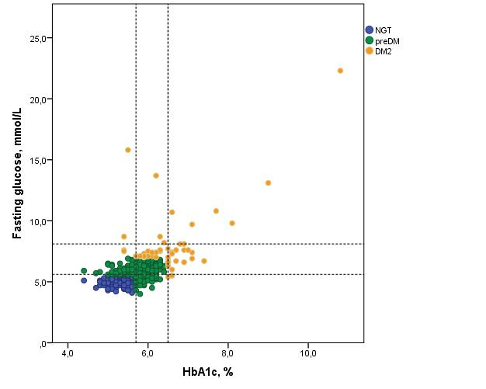

Figure 2. The Venn diagram shows the overlap between the diagnostics criteria of type 2 diabetes (DM2) and prediabetes (preDM) as fulfilled by FG and HbA1c.

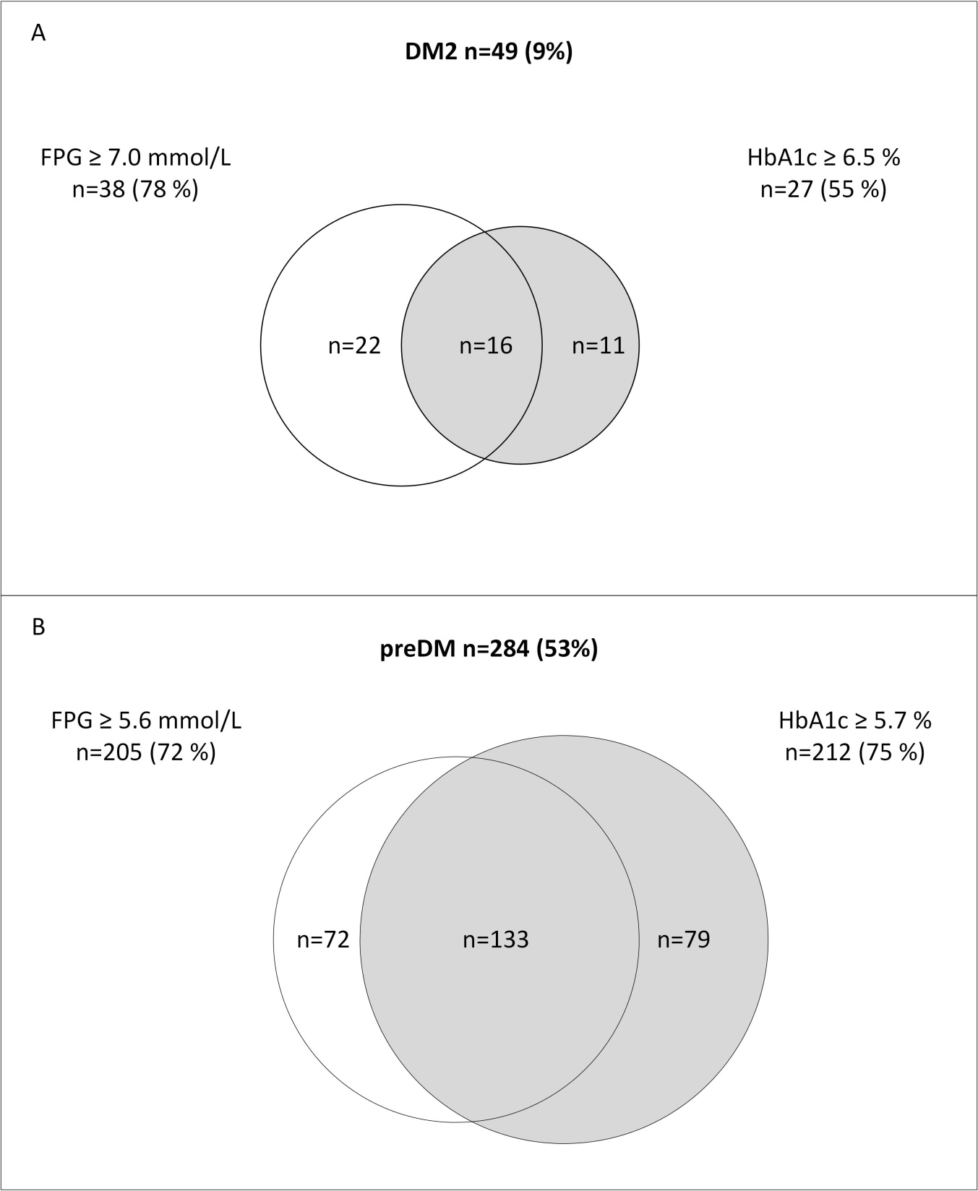

Figure 3. The figure shows the Receiver Operating Curve for fasting glucose (FG) and glycated A1c (HbA1c) in predicting glucose abnormalities defined as type 2 diabetes (Panel A) and prediabetes (Panel B) among patients with morbid obesity.
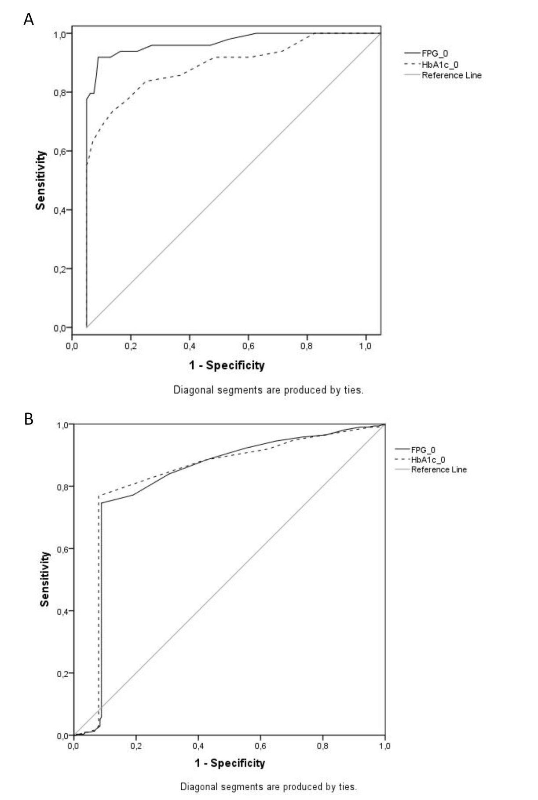
REFERENCES
[1] Hofso D, Jenssen T, Hager H, Roislien J, Hjelmesaeth J. Fasting plasma glucose in the screening for type 2 diabetes in morbidly obese subjects. Obes Surg 2010;20:302-7.
[2] Ibe A, Smith TC. Diabetes in US women on the rise independent of increasing BMI and other risk factors; a trend investigation of serial cross-sections. BMC Public Health 2014;14:954.
[3] Gyberg V, De BD, Kotseva K, De BG, Schnell O, Tuomilehto J, Wood D, Ryden L. Time-saving screening for diabetes in patients with coronary artery disease: a report from EUROASPIRE IV. BMJ Open 2016;6:e013835.
[4] Matheus AS, Tannus LR, Cobas RA, Palma CC, Negrato CA, Gomes MB. Impact of diabetes on cardiovascular disease: an update. Int J Hypertens 2013;2013:653789.
[5] Hu FB, Stampfer MJ, Haffner SM, Solomon CG, Willett WC, Manson JE. Elevated risk of cardiovascular disease prior to clinical diagnosis of type 2 diabetes. Diabetes Care 2002;25:1129-34.
[6] American Diabetes Association. Standards of Medical Care in Diabetes-2016: Summary of Revisions. Diabetes Care 2016;39 (Supplement 1):4-5.
[7] Standards of Medical Care in Diabetes: Summary of Revisions. Diabetes Care 2017;40:S4-S5.
[8] Guo F, Moellering DR, Garvey WT. Use of HbA1c for diagnoses of diabetes and prediabetes: comparison with diagnoses based on fasting and 2-hr glucose values and effects of gender, race, and age. Metab Syndr Relat Disord 2014;12:258-68.
[9] Barr RG, Nathan DM, Meigs JB, Singer DE. Tests of glycemia for the diagnosis of type 2 diabetes mellitus. Ann Intern Med 2002;137:263-72.
[10] World Medical Association Declaration of Helsinki: ethical principles for medical research involving human subjects. JAMA 2000;284:3043-5.
[11] Alberti KG, Eckel RH, Grundy SM, Zimmet PZ, Cleeman JI, Donato KA, Fruchart JC, James WP, Loria CM, Smith SC, Jr. Harmonizing the metabolic syndrome: a joint interim statement of the International Diabetes Federation Task Force on Epidemiology and Prevention; National Heart, Lung, and Blood Institute; American Heart Association; World Heart Federation; International Atherosclerosis Society; and International Association for the Study of Obesity. Circulation 2009;120:1640-5.
[12] Matthews DR, Hosker JP, Rudenski AS, Naylor BA, Treacher DF, Turner RC. Homeostasis model assessment: insulin resistance and beta-cell function from fasting plasma glucose and insulin concentrations in man. Diabetologia 1985;28:412-9.
[13] Friedewald WT, Levy RI, Fredrickson DS. Estimation of the Concentration of Low-Density Lipoprotein Cholesterol in Plasma, Without Use of the Preparative Ultracentrifuge. Clin Chem 1972;18:499-502.
[14] Magliano DJ, Barr EL, Zimmet PZ, Cameron AJ, Dunstan DW, Colagiuri S, Jolley D, Owen N, Phillips P, Tapp RJ, Welborn TA, Shaw JE. Glucose indices, health behaviors, and incidence of diabetes in Australia: the Australian Diabetes, Obesity and Lifestyle Study. Diabetes Care 2008;31:267-72.
[15] Lebovitz HE. Type 2 diabetes: an overview. Clin Chem 1999;45:1339-45.
[16] Rasmussen SS, Johansen NB, Witte DR, Borch-Johnsen K, Sandbaek A, Lauritzen T, Jorgensen ME. Incidence of register-based diabetes 10 years after a stepwise diabetes screening programme: the ADDITION-Denmark study. Diabetologia 2016;59:989-97.
[17] Jolle A, Midthjell K, Holmen J, Tuomilehto J, Carlsen SM, Shaw J, Asvold BO. Impact of sex and age on the performance of FINDRISC: the HUNT Study in Norway. BMJ Open Diabetes Res Care 2016;4:e000217.
[18] Du TT, Yin P, Zhang JH, Zhang D, Shi W, Yu XF. Comparison of the performance of HbA1c and fasting plasma glucose in identifying dysglycaemic status in Chinese high-risk subjects. Clin Exp Pharmacol Physiol 2013;40:63-8.
[19] Mann DM, Carson AP, Shimbo D, Fonseca V, Fox CS, Muntner P. Impact of A1C screening criterion on the diagnosis of pre-diabetes among U.S. adults. Diabetes Care 2010;33:2190-5.
[20] Ehehalt S, Wiegand S, Korner A, Schweizer R, Liesenkotter KP, Partsch CJ, Blumenstock G, Spielau U, Denzer C, Ranke MB, Neu A, Binder G, Wabitsch M, Kiess W, Reinehr T. Low association between fasting and OGTT stimulated glucose levels with HbA1c in overweight children and adolescents. Pediatr Diabetes 2016;
[21] Valderhaug TG, Jenssen T, Hartmann A, Midtvedt K, Holdaas H, Reisaeter AV, Hjelmesaeth J. Fasting plasma glucose and glycosylated hemoglobin in the screening for diabetes mellitus after renal transplantation. Transplantation 2009;88:429-34.
[22] Ehehalt S, Wiegand S, Korner A, Schweizer R, Liesenkotter KP, Partsch CJ, Blumenstock G, Spielau U, Denzer C, Ranke MB, Neu A, Binder G, Wabitsch M, Kiess W, Reinehr T. Diabetes screening in overweight and obese children and adolescents: choosing the right test. Eur J Pediatr 2017;176:89-97.
[23] Deeks JJ, Altman DG. Diagnostic tests 4: likelihood ratios. BMJ 2004;329:168-9.
[24] Bry L, Chen PC, Sacks DB. Effects of hemoglobin variants and chemically modified derivatives on assays for glycohemoglobin. Clin Chem 2001;47:153-63.
[25] Dalan R, Earnest A, Leow MK. Ethnic variation in the correlation between fasting glucose concentration and glycated hemoglobin (HbA1c). Endocr Pract 2013;19:812-7.
[26] Nasjonal brukerhåndbok i Medisinsk Biokjemi; Glukose, B/P2-8-2016. http://brukerhandboken.no/index.php?action=showtopic&topic=2731ba46bd01915df012
[27] Department of Noncommunicable Disease Management WHO. Screening for Type 2 Diabetes. Report of a World Health Organisation and International Diabetes Federation meeting. Geneva, World Health Organisation.2003. http://whqlibdoc.who.int/hq/2003/WHO_NMH_MNC_03.1.pdf

