Peripheral arthritis in patients with long-term inflammatory bowel disease. Results from 20 years of follow-up in the IBSEN study.
Running head: Arthritis in inflammatory bowel disease
Ossum Alvilde Maria^{1,2}, Palm Øyvind³, Cvancarova Milada⁴, Solberg Inger Camilla¹, Vatn Morten⁵, Moum Bjørn^{1,2}, Høivik Marte Lie¹ and the IBSEN study group.
¹Department of Gastroenterology, Oslo University Hospital, Oslo, Norway, ²Faculty of Medicine, University of Oslo, Oslo, Norway, ³Department of Rheumatology, Oslo University Hospital, Oslo, Norway, ⁴Faculty of Public Health, Oslo and Akershus University College, Oslo, Norway, ⁵EpiGen Institute, Campus Ahus, Akershus University Hospital.
Corresponding author: Alvilde M. Ossum, Oslo universitetssykehus, Department of Gastroenterology, Ullevål sykehus, Postboks 4956 Nydalen, 0242 Oslo
phone: +47 22118080, fax number: +47 22119942
Email: alvildenvei@gmail.com
Conference presentation: A preliminary abstract with a hard copy poster was presented in Vienna at the annual ECCO meeting in February 2018.

Peripheral arthritis in patients with long-term inflammatory bowel disease. Results from 20 years of follow-up in the IBSEN study.
Abstract:
Objectives: Peripheral arthritis and related musculoskeletal manifestations, often classified as peripheral spondyloarthritis, are frequently seen in patients with inflammatory bowel disease (IBD). Few long-term studies have reported on the prevalence of these conditions. The aim of this study was to determine the prevalence of IBD-related peripheral arthritis and peripheral spondyloarthritis in IBD patients during 20 years of disease course, and to assess whether these conditions were associated with the intestinal IBD severity and activity.
Materials and methods: In an inception cohort (the IBSEN study), IBD patients were followed prospectively for 20 years. At the 5 year follow-up the patients underwent a rheumatological examination and at the 20 year follow-up they completed a questionnaire with identical questions. When peripheral arthritis was characteristic and not explained by other specific diagnoses, it was defined as IBD-related peripheral arthritis. The Assessment of Spondyloarthritis International Society criteria were used to define peripheral spondyloarthritis, including patients with peripheral arthritis, enthesitis and/or dactylitis.
Results: After 20 years of follow-up, 441 patients were included (296 ulcerative colitis and 145 Crohn’s disease). The prevalence of IBD-related peripheral arthritis was 17.2 % and peripheral spondyloarthritis 27.9 % during the disease course. IBD severity and activity were not different between those with a history of IBD-related peripheral arthritis or peripheral spondyloarthritis and those without. A higher proportion of women had IBD-related peripheral arthritis and peripheral spondyloarthritis.
Conclusion: During 20 years of disease course, more than every sixth patient had suffered from IBD-related peripheral arthritis and every fourth from peripheral spondyloarthritis.
Keywords: Inflammatory bowel disease, peripheral arthritis, IBD-related peripheral arthritis, peripheral spondyloarthritis, spondyloarthritis, ulcerative colitis, Crohn’s disease
Introduction
Patients with inflammatory bowel disease (IBD) often suffer from musculoskeletal manifestations, including peripheral arthritis, enthesitis, dactylitis and inflammation of the spine (1). They can further be classified as spondyloarthritis (SpA) with the two subgroups: peripheral SpA (pSpA), largely overlapping with peripheral arthritis, and axial SpA, with predominantly spinal symptoms (2). Peripheral arthritis not explained by a specific diagnosis (i.e. rheumatoid arthiritis, infectious arthritis etc.) is often defined as IBD-related peripheral arthritis (3, 4).
IBD-related peripheral arthritis most frequently occur after the onset of intestinal symptoms and the arthritis attacks the knees and ankles (3); it is usually nonerosive and nondeforming (1). Moreover, IBD-related peripheral arthritis often accompanies intestinal IBD activity. Thus, flares of IBD-related peripheral arthritis may be prevented by treating intestinal inflammation (5). It is, however, not clear whether patients who experience episodes of IBD-related peripheral arthritis or other pSpA features during the disease course, have a more severe or active intestinal disease throughout the IBD course.
Although peripheral arthritis and pSpA are hallmarks of rheumatic manifestations in IBD, few studies have reported on the prevalence or the characteristics in patients with long-term IBD (6). We have recently reported on the prevalence of axial musculoskeletal manifestations in IBD patients 20 years after IBD diagnosis, including axial SpA (7), and in the current study we present peripheral musculoskeletal manifestations including pSpA.
The aim of this study was to determine the prevalence of IBD-related peripheral arthritis and pSpA in IBD patients 20 years after diagnosis. Furthermore, we wanted to assess whether the occurrence of IBD-related peripheral arthritis and pSpA during the disease course were associated with the long-term intestinal IBD severity and activity.
Materials and Methods
Patients and study design
The Inflammatory Bowel South-Eastern Norway (IBSEN) study included all newly diagnosed cases of IBD in four well-defined counties in south-eastern Norway (Oslo, Østfold, Telemark and Aust-Agder) from 1 January 1990 to 31 December 1993. The diagnosis was made according to the internationally accepted Lennard-Jones criteria for ulcerative colitis (UC) and Crohn’s disease (CD)(8). Scheduled follow-ups were conducted 1, 5, 10 and 20 years after inclusion and consisted of a clinical examination, structured interview, laboratory tests and colonoscopies. The design of the inception study and the follow-up studies, have been reported previously (9, 10).
At the 5-year follow-up, the patients underwent a standardised rheumatological assessment, including a clinical examination. Details regarding these methods and results have been published previously (3).
At the 20-year follow-up, a detailed questionnaire covering the symptoms of the peripheral rheumatic diseases investigated at the 5-year follow-up was used. The patients were also asked to report rheumatic diagnoses set by a physician (Appendix). Thus, the rheumatic manifestations recorded were based on data from the 5-year follow-up together with the detailed questionnaire at the 20-year follow-up.
Diagnostic criteria of peripheral arthritis, IBD-related peripheral arthritis and pSpA
A patient was defined as having peripheral arthritis when the diagnosis was set by a physician and based on the following; at least one episode with one or more painful and swollen/liquid-filled peripheral joints (Appendix). The time of onset of arthritis was not recorded in this study.
We defined peripheral arthritis as IBD-related when characteristic symptoms and distribution were present without other explanations, such as reported rheumatoid arthritis, psoriatic arthritis, gout, reactive arthritis, ankylosing spondylitis, juvenile arthritis and connective tissue diseases. Some patients reported to suffer from osteoarthritis in addition to peripheral arthritis. These were not excluded, assuming a physician-verified coexisting of the diseases had been present.
The Assessment of Spondyloarthritis International Society (ASAS) criteria (11) were used to define pSpA. According to these criteria, pSpA may be classified when peripheral arthritis, dactylitis and/or enthesitis are present in patients with IBD (Fig. 1). Patients who fulfil both the criteria for peripheral and axial SpA are considered to have predominantly axial symptoms and should not be counted as pSpA, but rather axial SpA with additional peripheral symptoms (7). These patients were therefore excluded from further analyses of pSpA (11). To avoid contamination of the group of patients used for comparison in the following statistical analyses, the patients with axial SpA and peripheral symptoms were also excluded from the comparison group (see section “IBD severity and activity). Dactylitis was registered when typical findings of thickened fingers in all lengths, so-called “sausage fingers”, had been present during the disease course. Enthesitis was diagnosed when signs of inflammation of the insertion of the Achilles tendon to the bone had been present.
IBD severity and activity
IBD severity and activity were assessed with the most extended distribution of UC, the location and behaviour of CD (as defined by the Montreal classification (12) during the 20 year follow-up), the need for IBD-specific medication and patient-reported IBD activity over time. The latter was assessed by four predefined curves reflecting the patients´ intestinal disease course from diagnosis onwards, which have been used in the IBSEN follow-ups (13). The curves were as follows: C1: initially highly active disease followed by remission or mild symptoms; C2: Initially low activity followed by an increase in the severity of intestinal symptoms. C3: chronic persistent activity; C4: chronic intermittent activity. For analytical reasons, curve 2 was left out of the calculations due to a small number of cases, and curves 3 and 4 were merged as chronic persistent or intermittent activity (7). The need for medication was defined as “ever used” during the 20-year follow-up.
Patients with IBD-related peripheral arthritis or pSpA were compared to the patients in the cohort without pSpA (including the 23 patients who concurrently fulfilled the criteria for peripheral and axial SpA) (Fig. 1). We compared the groups according to age, sex, IBD-diagnosis and variables indicative of IBD severity and activity.
Statistical analysis
Continuous variables were described with median and range, and categorical variables with counts and percentages. Crude comparisons between pairs of categorical data were performed using the chi-square test or Fisher’s exact test when appropriate. Crude comparisons between groups regarding continuous variables were performed using non-parametric methods, such as the Mann-Whitney Wilcoxon test. All tests were two-sided. To correct for multiple testing and account for the exploratory nature of our study, p-values<0.01 were considered statistically significant. All analyses were performed using SPSS version 25.
Results
After 20 years of follow-up in the IBSEN study, 599 patients (79.2 %) were alive. Of these patients, 441 (74 %) (296 UC and 145 CD patients) answered the questionnaire concerning rheumatic symptoms and diagnoses and were included in the current study (Fig. 2). Clinical characteristics at the 20-year follow-up are shown in Table 1.
Peripheral arthritis, IBD-related peripheral arthritis and pSpA
Peripheral arthritis was diagnosed in 104 IBD patients (23.9 %), 66 UC patients (22.5 %) and 38 CD patients (26.8 %) (p=0.3) (Fig. 3). Seventy-six patients (17.2 %) were defined as having IBD-related peripheral arthritis, 48 with UC (16.2 %) and 28 with CD (19.3 %) (p=0.4), including 33 cases (7.5 %) diagnosed between the rheumatological examinations at five years and the current evaluation. The diagnoses of non-IBD-related peripheral arthritis were linked to ankylosing spondylitis (n=12), rheumatoid arthritis (n=10), psoriatic arthritis (n=5), reactive arthritis (n=2), systemic lupus erythematosus (n=2), Sjögren’s syndrome (n=1), juvenile arthritis (n=1) and polymyalgia rheumatica (n=1).
In 146 (33.1 %) patients, peripheral arthritis, dactylitis and/or enthesitis had occurred since the onset of IBD. Twenty-three of these patients fulfilled the criteria for both pSpA and axial SpA, and were therefore excluded from the pSpA group in the current study, in accordance with the ASAS criteria (11). Thus, 123 patients (27.9 %) were classified as pSpA, 85 UC patients (28.7 %) and 38 CD patients (26.2 %) (p=0.6) (Fig. 3 and 4).
The proportions of females were significantly higher (p<0.01) in the groups with IBD-related peripheral arthritis (67.1 % females) and pSpA (61.8 % females) compared with the patients in the cohort without pSpA (46.4 % females) (Table 2).

IBD severity and activity
We found no association between the occurrence of IBD-related arthritis or pSpA and the UC extent, disease manifestation of CD (specified as intestinal location or behaviour according to the Montreal classification (12)), medication use, or the patients’ intestinal disease course (Table 2).
Discussion
This is the first population-based study reporting on the occurrence of peripheral arthritis and pSpA in IBD patients evaluated 20 years after diagnosis. A disease history of peripheral arthritis was present in 23.9 %, IBD-related peripheral arthritis in 17.2 %, and pSpA in 27.9 % of the patients. The occurrence of these rheumatic conditions was significantly associated with female gender, but not with IBD severity or activity at the 20-year investigation or the intestinal disease course.
IBD-related peripheral arthritis
The prevalence of IBD-related peripheral arthritis during the first 20 years of disease increased from 11.9 % (62/521) at the 5-year follow-up (3) to 17.2 % (76/441) at the 20-year follow-up. This modest increase over the last 15 years may be explained by a more quiescent intestinal disease throughout this part of the disease course, thereby reducing the risk of onset or relapse of IBD-related peripheral arthritis (14).
A comparison with previous studies is challenging due to variation in definitions of peripheral arthritis and whether the arthritis is defined as IBD-related or not. Moreover, similar population-based studies with this long follow-up time are lacking.
Malaty el al (15) reported a 7.3 % prevalence of peripheral arthritis among > 600 IBD patients when they investigated the local Veterans Affairs dataset in Houston. The arthritis occurred 2-17 years (mean 9.5 years) after the diagnosis of IBD. However, they did not specify whether only IBD-related peripheral arthritis was included. The lower prevalence compared to the current study might be explained by their retrospective design, which included only chart review and may have led to missing cases.
A similar prevalence of peripheral arthritis of 7.2 % (9.1 % CD and 5.5 % UC patients) was found in a European population-based multicentre inception IBD cohort by Isene et al (16), but their follow-up time was half the length of ours.
Ditisheim et al (17) found a prevalence of peripheral arthritis of 18.6 % in a large cross-sectional study with patients enrolled from 2006-2012, nested within the Swiss IBD cohort study. The median duration of IBD was 8 years. It is unclear, however, whether the reported peripheral arthritis was limited to IBD-related cases. The prevalence of peripheral arthritis reported is close to our results, although their follow-up time since diagnosis was shorter. They observed the highest frequency of arthritis among CD patients. Our data did indicate a slightly, but not significantly higher occurrence of peripheral and IBD-related arthritis in CD.
A retrospective multicentre study by Karmiris et al (4) from eight outpatient clinics in Greece reported a prevalence of IBD-related arthritis of 11.9 %. This was lower than in the current study, which may be explained by the retrospective study design and probably a shorter disease duration, which was not specified in the publication.
In accordance with the current study, arthritic extraintestinal manifestations were more prevalent in females than in males in the publications from Ditisheim et al (17) and Karmiris et al (4).
pSpA
The current SpA criteria were developed and validated by an expert group, the Assessment of SpondyloArthritis international Society (ASAS) in 2009 (11, 18). Previous criteria have not differentiated between peripheral and axial symptoms as the ASAS criteria do. When the ASAS criteria were developed, only 6 patients (2.3 %) had IBD in the group with pSpA (11). Since IBD itself is one of several SpA features, the criteria might be biased towards a higher prevalence of pSpA in an IBD population (Fig. 1).
We found a prevalence of pSpA of 27.9 %. Few previous studies have reported the prevalence of pSpA according to the ASAS criteria in IBD patients, but Stolwijk et al (19) investigated 350 IBD patients in an outpatient clinic in the Netherlands and found self-reported pSpA in 23.7 % of the patients after a mean IBD duration of 11.4 years. Thus, their result may be comparable to the 27.9 % reported after 20 years in the current study.
Van Erp et al (20) found a prevalence of pSpA according to the ASAS criteria of 5.9 % (15/255) among patients with a mean IBD duration of 15.8 years, which is shorter than in the current study. However, they based the diagnoses solely on cases referred to evaluation by a rheumatologist, which may have influenced the selection of cases, explaining some of the difference in prevalence.
IBD severity and activity
We found no association between a disease history of IBD-related peripheral arthritis or pSpA and IBD intestinal severity or activity at the 20-year follow-up. This may seem unexpected, as previous studies, including those of Van Erp et al (20) and Ditisheim et al (17), demonstrated an association between IBD disease activity and peripheral arthritis. The lack of association between arthritis and disease activity might be explained by the study design comparing a cumulative incidence with a cross-sectional value and the merging and exclusion of disease categories. Furthermore the medication use was an estimate based on ever use. Notably, a disease history of arthritis did not correlate with the different patient-reported intestinal disease courses, despite these curves reflecting the disease course over 20 years of follow-up.
The study was started before the introduction of biological treatment, thus few of the patients had received biologics during the 20 years of follow-up. Because biological medication may have a protective effect on inflammatory rheumatic diseases (21), the occurrence of arthritis may be lower in newer cohorts.
Strengths and limitations
This study is based on a well-characterised, prospective population-based inception cohort with a long-term follow-up. The response rate at the 20-year follow-up was high, which makes it a reliable source for prevalence studies among IBD patients. To estimate IBD-related arthritis, we carefully excluded arthritis of other causes that were recorded at the 5-year follow-up or patient-reported at the 20-year follow-up, and pSpA was assessed according to the internationally accepted classification criteria (11).
However, we did not repeat the clinical rheumatological examination, which was performed at the 5-year follow-up, due to limited resources. This may have influenced our results, but on the other hand, the questions at the 20-year follow-up were identical to those applied at the 5-year control. We are aware of the risk of recall bias, thus the questionnaire was detailed and formulated according to standard definitions of arthritis and dactylitis etc., in order to minimize recall bias and misclassification. It was also specified in the questionnaire that the reported diagnoses should have been confirmed by a physician.
We have estimated the prevalence of arthritis at two time points in this cohort, at five and 20 years since IBD diagnosis. The specific time of onset was not assessed, as this was considered to be an inaccurate measure, because of the long time since occurrence of arthritis in many cases. Hence the prevalence of arthritis at multiple time points and survival analyses were not feasible.
Radiological examination of the joints was not systematically performed; thus, it was not possible to evaluate objective signs of articular damage. However, we expect this to be of minor importance, considering that IBD-related arthritis usually is nondeforming and nonerosive (22).
Conclusion
More than every sixth patient had suffered from IBD-related peripheral arthritis and every fourth patient from pSpA during 20 years of disease course. These rheumatic manifestations were more prevalent in females. Awareness regarding peripheral musculoskeletal symptoms among IBD patients is important, considering the high numbers of IBD patients this can affect. This study indicates, however, that IBD-related peripheral arthritis or pSpA was not more prevalent among those reporting a high intestinal disease activity or a more severe disease course during long-term follow-up.
Acknowledgements
We thank all of the following members of the Inflammatory Bowel South-Eastern Norway (IBSEN) Study Group for participating in this study: Arne Borthne and Jørgen Jahnsen, Akershus University Hospital; Gert Huppertz-Hauss and Tomm Bernklev, Telemark Hospital Trust; Iril Kempski-Monstad, Randi Opheim, Oslo University Hospital; Pascal Klepp-Larsson, Lovisenberg Hospital; Njaal Stray, Diakonhjemmet Hospital; Magne Henriksen and Lars Petter Jelsness-Jørgensen, Østfold Hospital Trust; Øistein Hovde, Innlandet Hospital Trust; Ole Høie, Sørlandet Hospital; and May-Bente Bengtson, Vestfold Hospital Trust.
Author contributions
The authors Alvilde M. Ossum, Øyvind Palm, Bjørn Moum and Marte L. Høivik were involved in the study conceptualisation and designing. The authors Alvilde M. Ossum, Øyvind Palm, Inger Camilla Solberg, Morten Vatn, Bjørn Moum and Marte L. Høivik all contributed in the acquisition of data. The authors Alvilde M. Ossum, Øyvind Palm, Milada Cvancarova, Bjørn Moum and Marte L. Høivik also were interpreting the data and drafting the manuscript, and the statistical analyses were performed by Alvilde M. Ossum and Milada Cvancarova. All authors reviewed and provided critical revisions, and approved the final manuscript.
Funding
The IBSEN study has been supported by the South-Eastern Norway Regional Health Authority.
Conflict of Interest
Marte L. Høivik has received lecture fees from Takeda, MSD, Meda and Abbvie, research grants from Ferring, Tillots and Takeda, and advisory board fees from Takeda. Morten Vatn is a member of the Advisory Board of Genetic Analysis Company.
References
1. Vavricka SR, Schoepfer A, Scharl M, Lakatos PL, Navarini A, Rogler G. Extraintestinal Manifestations of Inflammatory Bowel Disease. Inflamm Bowel Dis. 2015;21(8):1982-92.
2. Rudwaleit M. New approaches to diagnosis and classification of axial and peripheral spondyloarthritis. Curr Opin Rheumatol. 2010;22(4):375-80.
3. Palm O, Moum B, Jahnsen J, Gran JT. The prevalence and incidence of peripheral arthritis in patients with inflammatory bowel disease, a prospective population-based study (the IBSEN study). Rheumatology (Oxford). 2001;40(11):1256-61.
4. Karmiris K, Avgerinos A, Tavernaraki A, Zeglinas C, Karatzas P, Koukouratos T, et al. Prevalence and Characteristics of Extra-intestinal Manifestations in a Large Cohort of Greek Patients with Inflammatory Bowel Disease. J Crohns Colitis. 2016;10(4):429-36.
5. Orchard TR. Management of arthritis in patients with inflammatory bowel disease. Gastroenterol Hepatol (N Y). 2012;8(5):327-9.
6. Salvarani C, Fries W. Clinical features and epidemiology of spondyloarthritides associated with inflammatory bowel disease. World J Gastroenterol. 2009;15(20):2449-55.
7. Ossum AM, Palm O, Lunder AK, Cvancarova M, Banitalebi H, Negard A, et al. Ankylosing Spondylitis and Axial Spondyloarthritis in Patients With Long-term Inflammatory Bowel Disease: Results From 20 Years of Follow-up in the IBSEN Study. J Crohns Colitis. 2018;12(1):96-104.
8. Lennard-Jones JE. Classification of inflammatory bowel disease. Scand J Gastroenterol Suppl. 1989;170:2-6; discussion 16-9.
9. Moum B, Vatn MH, Ekbom A, Fausa O, Aadland E, Lygren I, et al. Incidence of inflammatory bowel disease in southeastern Norway: evaluation of methods after 1 year of registration. Southeastern Norway IBD Study Group of Gastroenterologists. Digestion. 1995;56(5):377-81.
10. Solberg IC, Lygren I, Jahnsen J, Aadland E, Hoie O, Cvancarova M, et al. Clinical course during the first 10 years of ulcerative colitis: results from a population-based inception cohort (IBSEN Study). Scand J Gastroenterol. 2009;44(4):431-40.
11. Rudwaleit M, van der Heijde D, Landewe R, Akkoc N, Brandt J, Chou CT, et al. The Assessment of SpondyloArthritis International Society classification criteria for peripheral spondyloarthritis and for spondyloarthritis in general. Ann Rheum Dis. 2011;70(1):25-31.
12. Silverberg MS, Satsangi J, Ahmad T, Arnott ID, Bernstein CN, Brant SR, et al. Toward an integrated clinical, molecular and serological classification of inflammatory bowel disease: report of a Working Party of the 2005 Montreal World Congress of Gastroenterology. Can J Gastroenterol. 2005;19 Suppl A:5A-36A.
13. Solberg IC, Vatn MH, Hoie O, Stray N, Sauar J, Jahnsen J, et al. Clinical course in Crohn's disease: results of a Norwegian population-based ten-year follow-up study. Clin Gastroenterol Hepatol. 2007;5(12):1430-8.
14. Harbord M, Annese V, Vavricka SR, Allez M, Barreiro-de Acosta M, Boberg KM, et al. The First European Evidence-based Consensus on Extra-intestinal Manifestations in Inflammatory Bowel Disease. J Crohns Colitis. 2016;10(3):239-54.
15. Malaty HM, Lo GH, Hou JK. Characterization and prevalence of spondyloarthritis and peripheral arthritis among patients with inflammatory bowel disease. Clin Exp Gastroenterol. 2017;10:259-63.
16. Isene R, Bernklev T, Hoie O, Munkholm P, Tsianos E, Stockbrugger R, et al. Extraintestinal manifestations in Crohn's disease and ulcerative colitis: results from a prospective, population-based European inception cohort. Scand J Gastroenterol. 2015;50(3):300-5.
17. Ditisheim S, Fournier N, Juillerat P, Pittet V, Michetti P, Gabay C, et al. Inflammatory Articular Disease in Patients with Inflammatory Bowel Disease: Result of the Swiss IBD Cohort Study. Inflamm Bowel Dis. 2015;21(11):2598-604.
18. Sepriano A, Landewe R, van der Heijde D, Sieper J, Akkoc N, Brandt J, et al. Predictive validity of the ASAS classification criteria for axial and peripheral spondyloarthritis after follow-up in the ASAS cohort: a final analysis. Annals of the rheumatic diseases. 2016;75(6):1034-42.
19. Stolwijk C, Pierik M, Landewe R, Masclee A, van Tubergen A. Prevalence of self-reported spondyloarthritis features in a cohort of patients with inflammatory bowel disease. Can J Gastroenterol. 2013;27(4):199-205.
20. van Erp SJ, Brakenhoff LK, van Gaalen FA, van den Berg R, Fidder HH, Verspaget HW, et al. Classifying Back Pain and Peripheral Joint Complaints in Inflammatory Bowel Disease Patients: A Prospective Longitudinal Follow-up Study. Journal of Crohn's & colitis. 2016;10(2):166-75.
21. Vavricka SR, Scharl M, Gubler M, Rogler G. Biologics for extraintestinal manifestations of IBD. Curr Drug Targets. 2014;15(11):1064-73.
22. Orchard TR, Wordsworth BP, Jewell DP. Peripheral arthropathies in inflammatory bowel disease: their articular distribution and natural history. Gut. 1998;42(3):387-91.

Tables
Table 1. Demographics and IBD characteristics of the patients in the study at the 20-year follow-up. The UC extent is the maximal extent during the follow-up period. The CD location and behaviour is based on the Montreal classification (12) for the entire follow-up period. Immunomodulators constitute the use of azathioprine and methotrexate.

 | Ulcerative colitis  n=296  n (%) | Crohn’s disease  n=145  n (%)
Females | 152 (51.4) | 73 (50.3)
Age in years, median (range) | 53.4 (29.5 – 86.1) | 47.8 (27.4 - 94.0)
Current smoking status  Missing=5 | 43 (14.7) | 41 (28.7)
UC extent
Proctitis | 53 (17.9)
Left-sided | 97 (32.8)
Extensive colitis | 146 (49.3)
CD location
Ileal |  | 22 (15.2)
Colonic |  | 41 (28.3)
Ileocolonic |  | 82 (56.6)
Upper  Missing=5 |  | 1 (0.7)
CD behaviour
Non-stricturing,  non-penetrating |  | 54 (37.2)
Stricturing |  | 46 (31.7)
Penetrating |  | 45 (31.0)
Perianal disease  Missing=4 |  | 18 (12.8)
Medication
Biologicals  Missing=21 | 10 (3.6) | 34 (24.5)
Immunomodulators  Missing=3 | 35 (11.9) | 71 (49.0)

Table 2. Disease characteristics for the presented rheumatic patient groups at the 20-year follow-up, n (%).
*Significantly different from those without pSpA (p<0.01).
The CD location and behaviour were based on the Montreal classification. The patient-reported intestinal disease course curves for the follow-up period: C1: initially highly active disease followed by remission or mild symptoms; C3: chronic persistent activity; C4: chronic intermittent activity. Medication was defined as ever use of medication during the 20-year follow-up. “Immunomodulator” included azathioprine and methotrexate.
ªThe IBD patients excluding the patients fulfilling the criteria for pSpA (including the 23 patients who concurrently fulfilled the criteria for peripheral and axial SpA).
^{b}UC patients who had undergone colectomy were excluded from the SCCAI analyses. pSpA=peripheral spondyloarthritis. UC=ulcerative colitis. CD=Crohn’s disease. SCCAI=Simple Clinical Colitis Activity Index. HBI=Harvey-Bradshaw index.
 | pSpA  n=123  n (%) | IBD-related peripheral arthritis  n=76  n (%) | Patients without pSpAª  n=295  n (%)
Females | 76 (61.8)* | 51 (67.1)* | 137 (46.4)
Age, median (range) | 54.6 (34.3, 94.0) | 53.2 (34.3, 94.0) | 50.6 (27.4, 87.3)
UC (n=296) | 85 (28.7) | 48 (16.2) | 199 (67.2)
UC extent
Proctitis/left-sided | 44 (51.8) | 28 (58.3) | 100 (50.3)
Extensive colitis | 41 (48.2) | 20 (41.7) | 99 (49.7)
UC onset <40 years | 62 (72.9) | 36 (75.0) | 210 (70.9)
SCCAI score > 2,5  (missing n=3)^{b} | 19 (25.7)  (missing n=1) | 8 (19.5) | 34 (19.5)  (missing n=2)
CD (n=145) | 38 (26.2) | 28 (19.3) | 96 (66.2)
CD onset < 40 years | 24 (63.2)* | 20 (71.4) | 114 (78.6)
CD location
Ileal | 6 (15.8) | 5 (17.9) | 22 (15.2)
Colonic | 11 (28.9) | 7 (25.0) | 41 (28.3)
Ileocolonic | 21 (55.3) | 16 (57.1) | 82 (56.6)
CD behaviour
Non-stricturing, non- penetrating | 16 (42.1) | 8 (28.6) | 54 (37.2)
Stricturing/penetrating | 22 (57.9) | 20 (71.4) | 91 (62.8)
HBI score > 4 | 5 (18.5)  (missing n=11) | 7 (30.4)  (missing n=5) | 36 (24.8)  (missing n=28)
Patient-reported intestinal disease course | (missing n=4,  curve 2 n=3) | (missing n=2,  curve 2 n=1) | (missing n=1,  curve 2 n=8)
C1 | 83 (71.6) | 52 (71.2) | 197 (68.9)
C3/C4 | 33 (28.4) | 21 (28.8) | 89(31.1)
Medication ever used
Corticosteroids | 76 (62.3)  (missing n=1) | 48 (63.2) | 172 (58.5)  (missing n=1)
Biologics | 11 (9.4)  (missing n=6) | 8 (10.8)  (missing n=2) | 28 (10.0)  (missing n=14)
Immunomodulators | 27 (22.3)  (missing n=2) | 18 (24.0)  (missing n=1) | 71 (24.1)  (missing n=1)

Figures
Fig. 1.
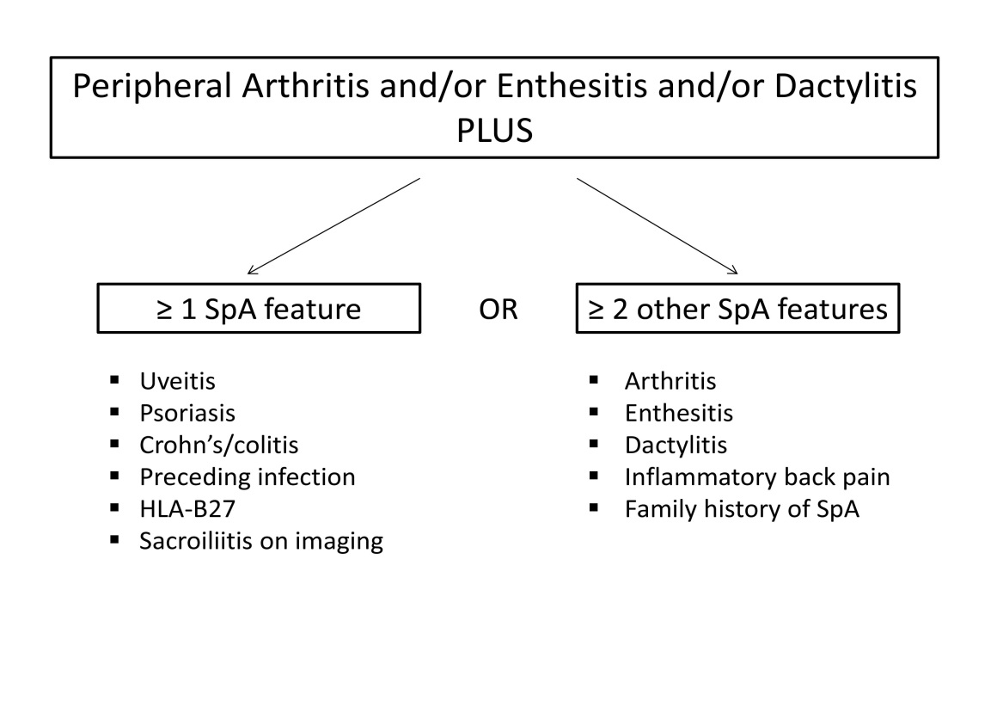
Fig. 2.
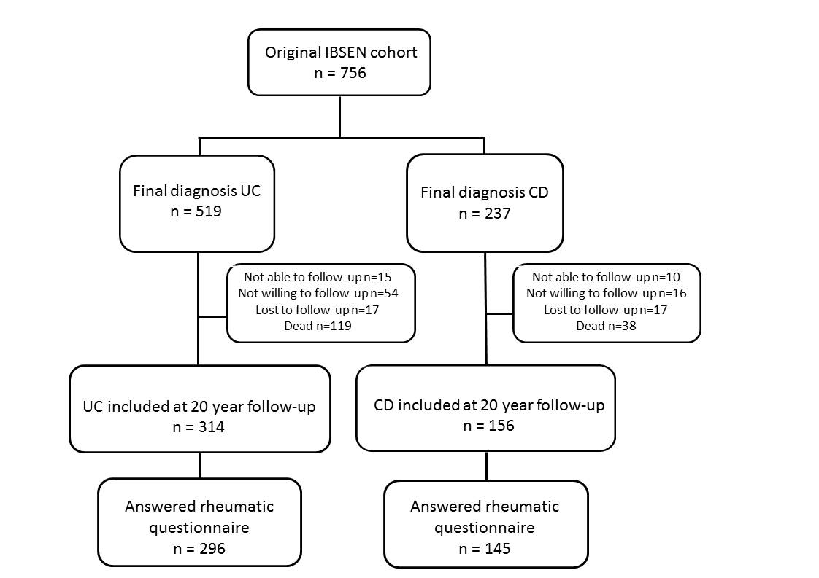

Fig. 3.
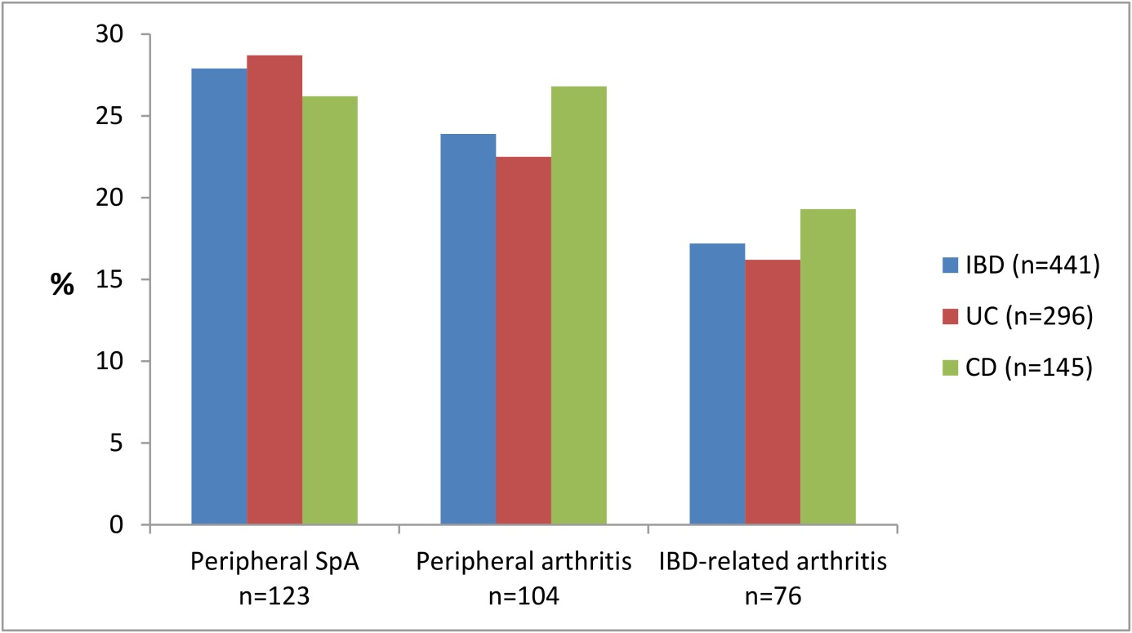
Fig. 4.
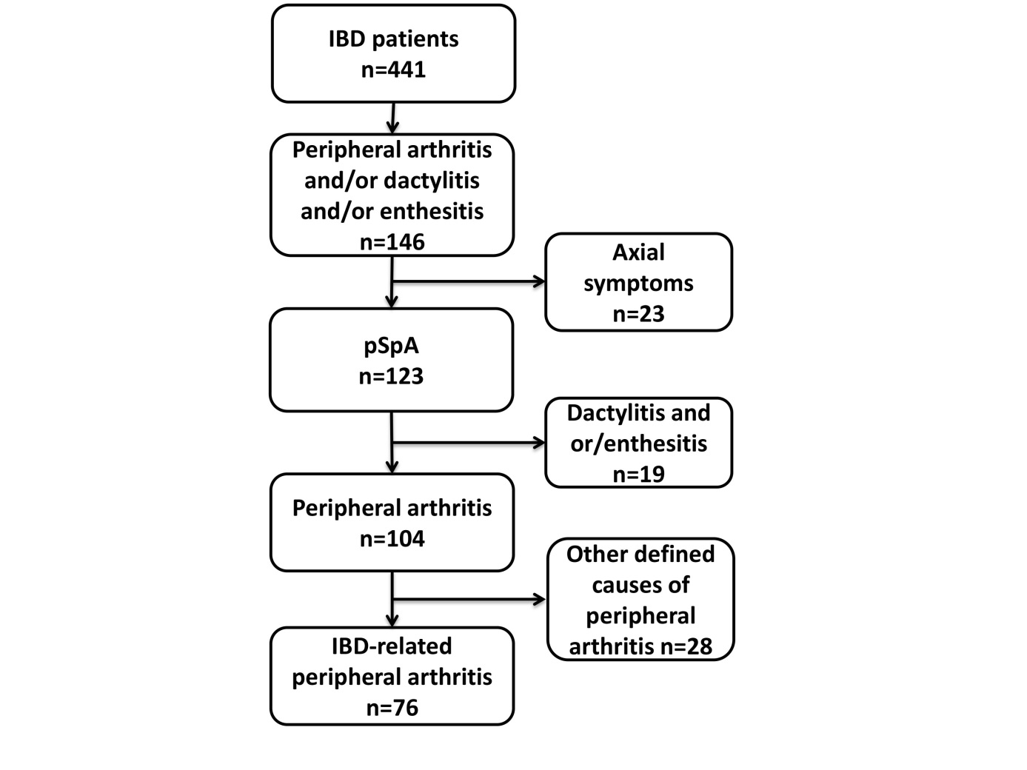
Figure captions:
Fig. 1. The Assessment of Spondyloarthritis International Society (ASAS) classification criteria for peripheral spondyloarthritis (pSpA) (11).

Fig. 2. Flow chart of the participants at inclusion and the 20-year follow-up. UC=ulcerative colitis. CD=Crohn’s disease.
Fig. 3. Peripheral rheumatic manifestations according to IBD diagnosis 20 years after diagnosis. Peripheral spondyloarthritis (SpA) was diagnosed according to the Assessment of Spondyloarthritis International Society (ASAS) criteria (11). No statistically significant differences between UC (ulcerative colitis) and CD (Crohn’s disease) were found.
Fig. 4. Flow chart of the IBD patients with peripheral rheumatic manifestations assessed at the 20-year follow-up.

